sFramework using Edge/Fog-to-Cloud Pipeline with MQTT, Node-RED, and
Objective:
To simulate a People-Process-Data-Things (PPDT) IoE framework in which sensor data flows through an edge/fog-to-cloud pipeline using MQTT and Node-RED, and to benchmark simulated 5G and 6G communication for IoE applications in terms of throughput, latency, reliability and energy efficiency.
Procedure:
- Part A: simulate 120 sensor devices (Sensor_001 to Sensor_120), each linked to one person (Operator_A, Operator_B, Technician_C, Admin_D) and one process (Monitoring, Alerting, Control, Logging), with a temperature reading drawn from a normal distribution (mean 28, SD 4).
- Model message delivery: MQTT succeeds with probability 0.97 and Node-RED with probability 0.985; a message is delivered only if both succeed.
- Assign each device simulated processing latencies at the edge (mean 18 ms), fog (mean 35 ms) and cloud (mean 70 ms), and compute the delivery rate and the average latency at each tier.
- Part B: generate 1,000 samples each for 5G and 6G of throughput, latency, reliability and energy per MB from normal distributions with set limits, and take the mean of each metric.
- Plot IoE delivery, edge/fog/cloud latency, 5G vs 6G throughput and 5G vs 6G latency.
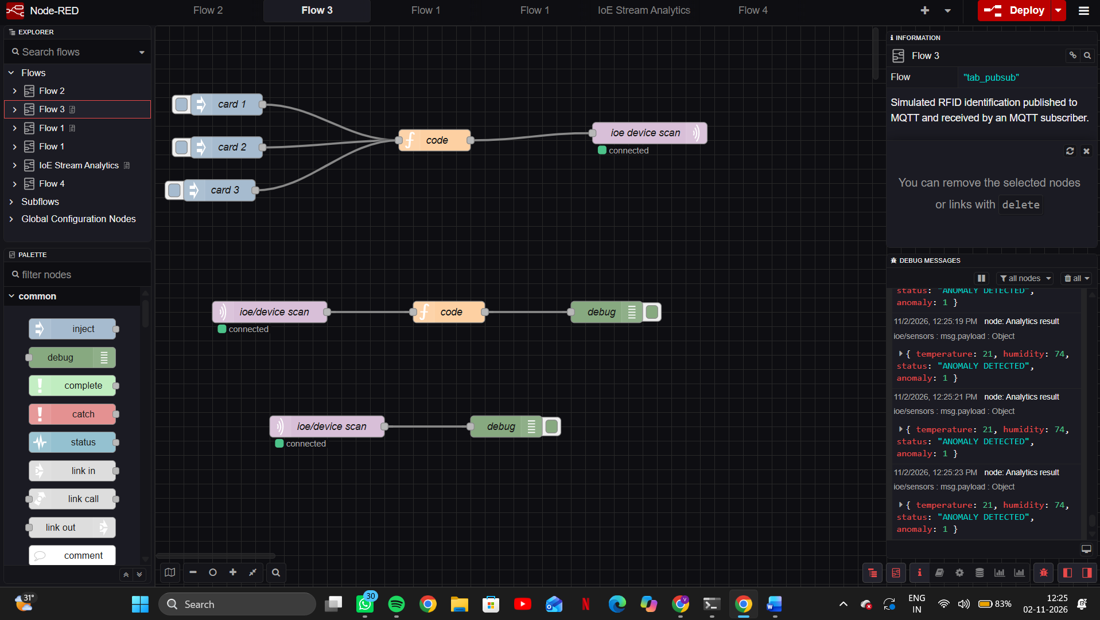
Result:
The simulated PPDT IoE framework delivered 95.00% of device messages through MQTT and Node-RED, and latency was lowest at the edge and highest at the cloud, so processing data close to the things reduces delay for time-sensitive IoE tasks. In the benchmark, 6G outperformed 5G on all four measures: throughput, latency, reliability and energy efficiency. All figures are synthetic simulation values, not measured network results.

